**Project Abstract**

**Version 1.0**

**<cafe management System>**

The Cafe Management System is a web-based application designed to streamline the day-to-day operations of a cafe. The system includes modules for managing orders, inventory, staff, and customer information.The system is also designed to provide valuable insights into customer behavior and preferences, enabling cafe owners to make data-driven decisions to improve their business.

The Cafe Management System has the potential to increase efficiency, reduce errors, and improve customer satisfaction in cafes of all sizes.

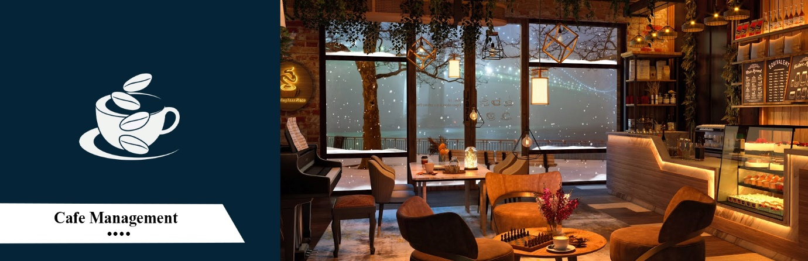

|  |  |  |  |
| --- | --- | --- | --- |
|  | Prepared By / Last Updated By | Reviewed by | Approved By |
| Name | Sreyash Parjane | <Trainer/Project Governance Representative/Cohort Mentor to fill> | <Trainer/Project Governance Representative/Cohort Mentor to fill> |
| Role |  |  |  |
| Signature |  |  |  |
| Date |  |  |  |

Table of Contents

1.0 Purpose of this document 4

2.0 Business Case 4

3.0 Appendices 4

3.1 Glossary 4

3.2 Other 4

4.0 Terms & Conditions 5

5.0 Change Log 5

# Purpose of this document

The main purpose this project, is to provide a concise and informative summary of the key features, benefits, and potential business cases for the system. The document is intended to be a high-level overview that can be potential customers, and development team members to communicate the value proposition of the Cafe Management System.The system is designed to solve, and how it will help cafes operate more efficiently and provide better customer experiences.

Overall, the purpose of this project, to help customers understand its potential value and to generate interest in the system as a solution to the challenges faced by cafes.

# Business Case

**Registration of Customer Account:** To ensure security, the registration page should implement measures to protect user data, so user can log into the café.

**Search for beverages frpm menu:** user can search for the for beverages and add the beverages.

**Managing the Orders:** user can manage their oreders also delete for the same.

**Billing Managemrnt :** cafe management system can help cafes manage these bills more effectively.

# Technology to be used:

* Fronend – Angular
* Database – MySQL
* Language – Java
* Backend – Spring-boot,Spring Data JPA,MySQL
* IDE – Eclipse, VS code

## Glossary

|  |  |
| --- | --- |
| **Acronyms** | **Definitions** |
|  |  |

## Other

# Terms & Conditions

***Disclaimer: Please do not circulate or distribute this document outside of Cognizant Network, We have a Zero Tolerance Policy. Kindly adhere to 100% Compliance at all times.***

# Change Log

*Please note that this table needs to be maintained even if a Configuration Management tool is used.*

|  |  |  |  |  |
| --- | --- | --- | --- | --- |
| Version Number | Changes made | | | |
| V<n.n> | *<If the change details are not explicitly documented in the table below, reference should be provided here>* | | | |
| Page no | Changed by | Effective date | Changes effected |
|  |  |  |  |
|  |  |  |  |
|  |  |  |  |
|  |  |  |  |